**TEAM KUBWA**

**Description**  
Urban green spaces include parks, community gardens, and areas of vegetation in cities.

This project aligns with SDG 11 - Sustainable Cities and Communities. It focuses on making cities inclusive, safe, resilient, and sustainable.

**Scope**  
The system will handle:

* Tracking maintenance activities (e.g., mowing, watering, repairs, etc.).
* Monitoring community use of spaces (e.g., events and gatherings).
* Recording environmental impact (e.g., air quality and plant diversity).

**Objectives**

1. Create a system to schedule and track green space maintenance.
2. Store and retrieve information about community use of these spaces.
3. Track environmental data, such as pollution levels and species diversity.

**Stakeholders**  
The main stakeholders include city officials, community members, and environmental groups.

**Entity Relationship Diagram (ERD)**

**Strong Entities**

**1.Green Space**

Attributes: Space ID, Name, Location (City, Region, Street), Size, Type, Date Created

**Community Use**

Attributes: Use ID, Space ID, Event Name, Date, Participant Count, Organizer

**Environmental Data**

Attributes: Data ID, Space ID, Air Quality Index, Biodiversity Index, Record Date

**Maintenance Activity**

Attributes: Activity ID, Maintenance ID, Activity Type

**Weak Entities**

1. **Maintenance Records**
   * Attributes: Space ID, Date, Activity, Cost, Performed By

**Problem Description**

Parks, and other urban green spaces such as gardens, playgrounds, etc. are important for improving the quality of life in urban areas. Nonetheless, effective management of these spaces can prove difficult because of insufficient upkeep; lack of community usage; and adverse ecological consequences. To address these challenges, we have proposed a database:

1.Maintenance Tracking: Routine maintenance and preventive measures to keep the greenery clean, secure there and remove any unwanted debris.

2.Monitoring Community Use: How and when are these spaces being used by the community for events or activities — and how can programming promote more?

3.Environmental Impact Valuation: Quantifying the value of ecosystem services provided by urban green spaces, including air quality improvement and biodiversity enhancement, to justify their conservation and expansion.

**Consistency with Sustainable Development Goals (SDG)**

This commitment also serves the SDGs, notably:

SDG 11: Sustainable Cities and Communities: The project encourages the development and maintenance of green spaces, which in turn promotes sustainable urbanization by providing safe, inclusive, accessible public spaces.

SDG 13: Climate Action: Green spaces contribute to climate change adaptation by acting as carbon sinks, eliminating urban heat islands and improving biodiversity.

SDG 15: Life on Land: Protecting and restoring urban green spaces contributes to the conservation of terrestrial ecosystems and biodiversity.

**Relevance in the Kenyan Context**

Kenya, like many rapidly urbanizing countries, faces significant environmental and social challenges due to urbanization[1](https://www.mdpi.com/2071-1050/15/15/11873?form=MG0AV3" \t "_blank). Urban green spaces in Kenya offer numerous benefits:

1. **Environmental Benefits**: Green spaces help reduce air and water pollution, regulate temperatures, and increase biodiversity[1](https://www.mdpi.com/2071-1050/15/15/11873?form=MG0AV3" \t "_blank).
2. **Social and Economic Benefits**: They provide recreational areas for communities, promote social cohesion, and can attract tourism and investment[2](https://scholars.aku.edu/en/publications/promoting-sustainable-environments-through-urban-green-spaces-ins?form=MG0AV3" \t "_blank).
3. **Health Benefits**: Access to green spaces is linked to improved mental and physical health, offering residents a place to exercise, relax, and connect with nature[2](https://scholars.aku.edu/en/publications/promoting-sustainable-environments-through-urban-green-spaces-ins?form=MG0AV3" \t "_blank).

In Kenya, urban green spaces like Nairobi City Park and John Michuki Memorial Park have shown the potential to enhance urban living by providing these benefits[1](https://www.mdpi.com/2071-1050/15/15/11873?form=MG0AV3" \t "_blank). However, challenges such as population growth, lack of public open spaces, and overdevelopment need to be addressed to maximize their impact[1](https://www.mdpi.com/2071-1050/15/15/11873?form=MG0AV3" \t "_blank).

By implementing a database to manage these spaces, Kenya can ensure their sustainable development and maintenance, ultimately contributing to a healthier, more sustainable urban environment.

**Project Scope**

It envisages creating an overarching database system to manage urban green spaces. It will log maintenance, use by the community and record environmental impact to ensure these spaces are maintained, utilized and working for the environment.

**Specific Objectives**

Effective Maintenance Management:

Plan and keep track of maintenance events.

Keep track of department spend and resource allocation for maintenance activities.

Better Community Involvement:

Track local events and initiatives.

Detect trends of community usage to better leverage our space.

Environmental Assessment Approval:

Collect and record environmental data like air quality, biodiversity.

Green space ecosystem services aim at examining the challenge of data analysis

Data-Driven Decision Making:

Insights for urban planners and policymakers

Core Functionalities and Features

User Management:

Permission system for admin, maintenance and community organizer

Green Space Management:

Insert, edit and delete green spaces records.

Live statistics about park and forest are recorded such as park or forest location, size and type.

Maintenance Tracking:

After, it allows you to schedule maintenance activities and assign the staff for such tasks.

Keep track of maintenance activities (date, type, cost).

Build reports for the maintenance history and expenses

Community Use Monitoring:

Record community events and activities including date, type and number of participants.

Track the activities with higher frequency to understand the most used functionalities as well as analyze the peak usage hours.

Monitoring Environmental Impact:

Used to track environmental data like air quality, biodiversity index and water quality.

Create reports that track the environmental impact over time.

Reporting and Analytics:

Produce a variety of reports for maintenance, local community use, and environmental impact.

Develop visualizations and dashboards to allow stakeholders to grasp the trends within the data.

Notifications and Alerts:

Remind the maintenance activities which are planned.

Alert administrators about any big fluctuations in environmental indicators.

Connecting to Different Type of Platforms:

Enable GIS (Geographic Information Systems) Integration

Allow for compatibility with other urban management system by enabling data export and import functionalities

**Main Stakeholders**

Urban Planners and Local Government Officials

Maintenance Staff

Related Topics Community Members Community Organizations

Environmental Research and Advocacy Groups

Policy Makers

**How this Project Meet Their Needs**

Urban Planners and Local Government Officials

Needs: Efficient management of urban green spaces, data-driven decision-making, and planning for future developments.

Solution: Urban spaces are easier to manage with data-driven decision making and future planning.

Why the Project is Helpful: This database allows planners to access extensive information related to maintenance, community use, and environmental impact of canopies, facilitating more suited decisions. Reports and analytics aid in planning new green spaces (such as parks and gardens) or improving the existing ones.

Maintenance Staff

Requirements: Scheduled calendars with assigned tasks and recorded maintenance activities.

Project relevance — Scheduling maintenance tasks and tracking them via the system, thus allowing timely interventions. This can also help in keeping a tab on ongoing costs and who is using what, which streamlines maintenance.

Local Community Groups and Organizations

Essential prerequisites: Access to well-maintained green spaces for recreation, events, and community activities.

How The Project Helps — The database tracks community use as well so events and activities can be organized around community needs. To maintain parks and ensure that they are safe for people to use.

Environmental Scientist and NGOs

Activists & Researchers: Investigation of the environmental effects urban green spaces are having

Why the Project is Helpful: By allowing these environmental metrics to be recorded, including air quality and biodiversity data for research. And this data can be helpful to support broader green space protection and development.

Policy Makers

Demand: Policy and regulation to support and govern urban green spaces is well-informed by the evidence.

Project Contribution: Database of reports and analytics on the benefits of green spaces to inform policy advice for sustainable urban development

Problem Description

Parks, and other urban green spaces such as gardens, playgrounds, etc. are important for improving the quality of life in urban areas. Nonetheless, effective management of these spaces can prove difficult because of insufficient upkeep; lack of community usage; and adverse ecological consequences. To address these challenges, we have proposed a database.

Entity-Relationship Diagram (ERD)

**Entities and Attributes**

Strong Entities and Attributes:

1. **Greenspace**

Attributes: GreenspaceID(Primary key), name, type, area, locationID(Foreign key), status, created date, age.

2. **Location**

Attributes: LocationID (Primary Key), city, neighbourhood, coordinates, population density, address.

3. **Event**

Attributes: EventID (Primary Key), Name, greenspace(Foreign key), date, attendance count, total attendees.

4. **User**

Attributes: UserID (Primary Key), gender, city, visit frequency, fullName, contact no.s, feedback.

**Weak entities and attributes:**

1. Maintenance

Attributes: MaintenanceID (Primary Key), greenspace ID(Foreign key),date,type,cost,performed by.

2. Environmental impact

Attributes: Impact ID (Primary Key),greenspaceId(Foreign key),air quality index, noise level, pollutants,biodiversity index.

3. User Activity

Attributes: ActivityID (Primary Key), greenspaceID(Foreign key), description, date, duration, total time.

4. Facility

Attributes: FacilityID (Primary Key),greenspaceID, facilityType.

Relationships

1. Maintenance has a one-to-many relationship with Facility (each maintenance record can cover multiple facilities)[one-to-many].

2. Greenspace has one-to-many relationship with environmental impact.

(GreenSpace can be affected by various environmental impacts)[one-to-many].

3. Greenspace has a one-to-one relationship with Location.

GreenSpace is located at a Location (many-to-one relationship).

4. Event has a many to one relationship with Greenspace.

Many events are hosted at a specific Greenspace (many-to-one relationship).

5. Greenspace shares a one-to-many relationship with maintenance.

Greenspace can hold multiple maintenance for its facilities(one-to-many)

6. User shares a one-to-many relationship with useractivity.

A user can participate in various activities.(one-to-many).

7. Greenspace shares a one-to-many relationship with useractivity.

A greenspace can host multiple activities for the users to participate i

(One-to-many)

8. Facility share a many-to-one relationship with greenspace.

Many facilities are owned by one greenspace(many-to-one).

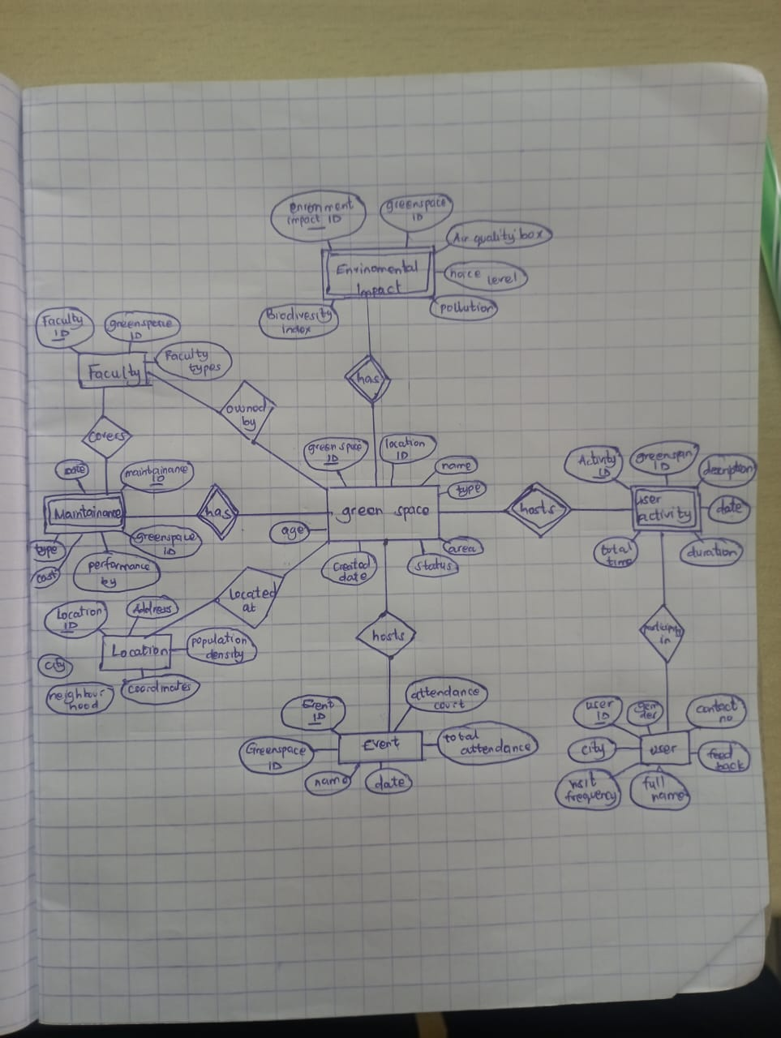

DATABASE SCHEMA